Format for the Paper Submission
Please strictly follow the guidelines while submission of the paper.
Single column, Margin: Normal
Title: Times New Roman 16, centrally aligned
Author name: Times New Roman:12, centrally aligned
Affiliation: times new Roman 12, italics, centrally aligned

Headings: Bold, times new Roman 12,
Subheadings: Times New Roman, 12, Italics,
No numbering for headings and subheadings
Text in the body of the manuscript:
Times new Roman, Size:12; Spacing: 1.5, justified
Table and Figures:
Centre aligned, duly numbered.
Example:
Table:1 Description of the table
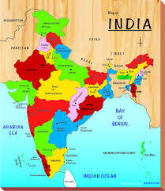
Fig.1 Political map of India
Citation and References:
Please follow APA style strictly. Please don’t use footnote.
Citation: author-date
Example:
Abbood (2009), Arthur (2018), Banerjee and Pasupuleti (2019), Chen et.al., (2015)
Reference: Alphabetically arranged.
Abbood, D.W., 2009. An experimental model for flow through porous media using water filter. Presented at the Thirteenth international water technology conference.
Arthur, J., 2018. Porous Media Flow Transitioning into the Forchheimer Regime: a PIV Study. J. Appl. Fluid Mech. 11, 297–307.
Banerjee, A., Pasupuleti, S., 2019. Effect of convergent boundaries on post laminar flow through porous media. Powder Technol. 342, 288–300.
Chen, Y.-F., Zhou, J.-Q., Hu, S.-H., Hu, R., Zhou, C.-B., 2015. Evaluation of Forchheimer equation coefficients for non-Darcy flow in deformable rough-walled fractures. J. Hydrol. 529, 993–1006.

